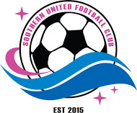

SOUTHERN UNITED FC
Refund Policy

GENERAL

Whilst we make every effort to find the right team for each player, there are times when this doesn’t happen and de-registration is requested. As a club, we incur many costs at various stages throughout the season, and our refund policy takes these into account. Our refund policy is as follows:

- If we have been unable to place you into a team, we will refund 100% of your registration fee
- If we have placed you into a team, but you decide to de-register after the team list has been published, but before the start of the competition, we will refund you 75% of your registration fee
- If you de-register after the start of the competition, but before the end of May, we will refund you 50% of your registration fee
- If you de-register from June 1 onwards, we are unable to offer a refund

Approval Date: |  | 12/6/2021
Review Date: |  | 12/6/2022
Version No: |  | 1.0
President: | Sign: |  | Name: Darren Butler
Vice-President: | Sign: |  | Name

